Date: 08/08/2024
Roll No. and Name: 24ITC087 KHUSH PITHVA
Course Code and Name: 1CS501 Computer Programming
Practical No: 1(a)
AIM: Demonstration of CodeBlocks IDE. Make use of CodeBlocks to write and compile a simple C program ("Hello World")

Methodology followed:
#include<stdio.h>
int main()
{
printf("hello world \n");
return 0;
}
output:

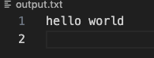

Practical No: 1(b)
AIM : Illustrate the use of scanf and printf function to read and display values of different types of variables, address of a variable in C language

Methodology followed:
#include <stdio.h>
int main()
{
int n;
float m;
scanf("%d",&n);
scanf("%f",&m);
printf("%d \t%f ",n,m);
return 0;
}
Input/output:

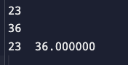
Practical No: 1(c)
AIM : Demonstrate different escape sequences.
Methodology followed:
#include <stdio.h>
int main()
{
printf("hello\nworld\n");
// \n Inserts a new line in the text.
printf("nice\t try");
// \t Inserts a horizontal tab
return 0;
}

intput/output:
